
HOME | ABOUT A/PROF PAUL HARVIE | TREATMENTS | CONTACT | 03 6214 3060

LOGO FONTS: Gitsey & Carnival VP
COLOUR: #3e6493
#0598fc
Image library: https://drive.google.com/drive/folders/1dnCueNoUCZCPn-ozKeiZC38mMD7O6k_p?usp=sharing

HOME
Dr Paul Howie
Associate Professor of Orthopaedic Surgery
BEng(Hons), MBChB, MRCS, FRCS, MD, FRACS, FAOrthA
Hobart Orthopaedic Surgeon | Hip & Knee Surgery

Providing comprehensive assessment and management of hip and knee conditions, including arthritis care, joint replacement surgery, and sports-related injuries for patients across Hobart and Tasmania.

Get In Touch


Hero Image:

Comprehensive, evidence-based care for hip and knee conditions in Hobart and throughout Tasmania.

ABOUT DR PAUL HARVIE
ORTHOPAEDIC HIP & KNEE SURGEON
Associate Professor of Orthopaedic Surgery
BEng(Hons), MBChB, MRCS, FRCS, MD, FRACS, FAOrthA
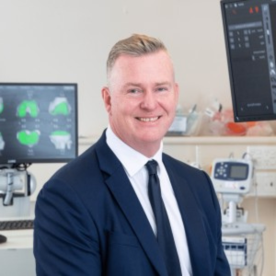
Dr Paul Harvie is a Hobart-based orthopaedic surgeon with a particular focus on hip and knee conditions, including arthritis, joint degeneration, sports injuries and orthopaedic trauma. His practice includes primary and revision joint replacement surgery, robotic-assisted knee surgery, and anterior approach hip replacement.

Associate Professor Harvie works within a collaborative surgical team to support patient care throughout the perioperative period. Surgical patients are reviewed daily by trusted medical colleagues, ensuring continuity of care and careful monitoring during recovery.

Dr Harvie performs patient specific total hip replacement using a minimally invasive direct anterior approach, incorporating assessment of spino-pelvic motion to assist with component positioning. He also performs robotic-assisted total and partial knee replacement surgery, as well as revision hip and knee replacement procedures. He offers hip resurfacing using both metal and ceramic bearing options with patient-specific instrumentation. Dr Harvie also performs radiofrequency ablation for selected patients with hip and knee arthritis or trochanteric bursitis, where appropriate.

Dr Paul Harvie consults from a purpose-designed orthopaedic suite in central Hobart, with convenient ground floor access and nearby parking.

Expertise & Background
Associate Professor Harvie is a UK-trained orthopaedic surgeon holding dual accreditation with the Royal College of Surgeons of England and the Royal Australasian College of Surgeons. Originally trained as an engineer, he completed an undergraduate engineering degree before pursuing medicine. He undertook a Medical Research Doctorate at the Botnar Research Centre, University of Oxford, prior to completing the six-year Oxford Orthopaedic Training Program. Following this, he undertook additional fellowship training in Perth (Australia), Oxford and Bristol, with a focus on complex primary and revision hip and knee replacement surgery.

In addition to his clinical practice, Associate Professor Harvie is involved in teaching and research in orthopaedics.

SURGICAL INTERESTS
• Direct Anterior Hip Replacement
• Primary Total Hip Replacement
• Revision Hip Replacement
• Hip Resurfacing
• Robotic-Assisted Total & Partial Knee Replacement
• Primary Total Knee Replacement
• Revision Knee Replacement
• Arthroscopic Hip & Knee Surgery
• Hip & Knee Radiofrequency Ablation
• Orthopaedic Trauma & Reconstruction

Arrange a Consultation


TREATMENTS
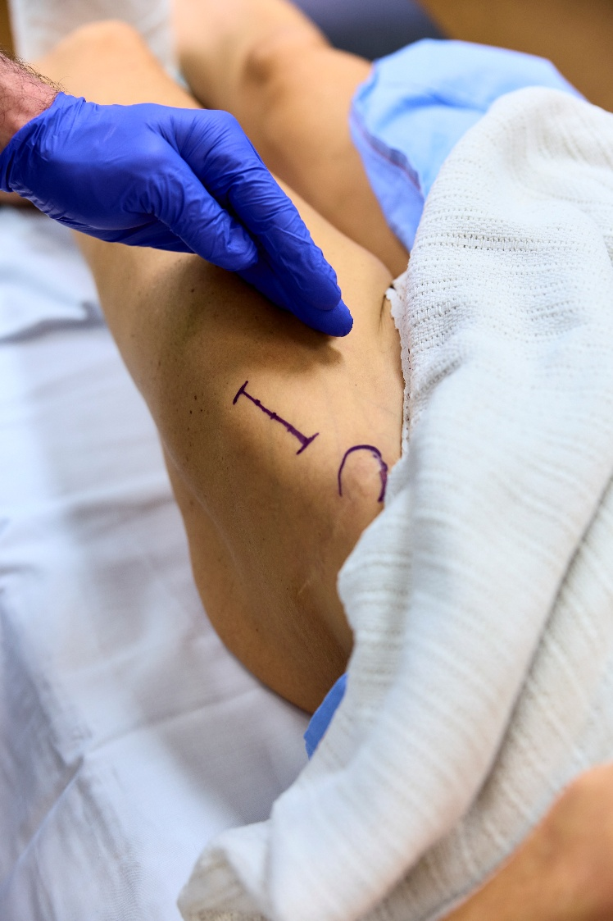
Anterior Hip Replacement Surgery
Dr Paul Harvie performs total hip replacement using the direct anterior approach, alongside other contemporary surgical techniques. The choice of approach is determined following careful assessment of each patient’s anatomy, diagnosis, lifestyle requirements, and surgical goals.

He incorporates detailed pre-operative planning and, patient specific instrumentation to support implant positioning and alignment. Consideration of spino-pelvic motion may also form part of surgical planning to assist with component orientation.

Where suitable, muscle-sparing techniques are utilised to facilitate early mobilisation and structured rehabilitation. The overall aim is to relieve pain, improve joint function, and support a safe return to daily activities.

Send an Enquiry

Robotic-Assisted Knee Replacement Surgery
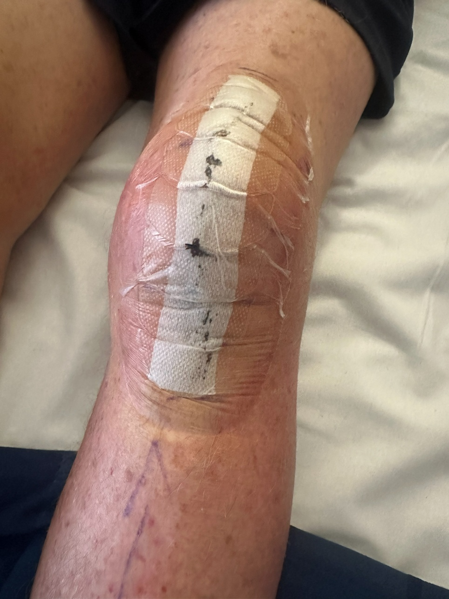
Dr Paul Harvie performs robotic-assisted total and partial knee replacement surgery as part of his management of knee arthritis and joint degeneration. Robotic technology is used to assist with detailed pre-operative planning and intra-operative guidance, supporting accurate bone preparation and implant positioning tailored to each patient’s individual anatomy.

Where appropriate, patient-specific planning is utilised to assess the natural alignment and joint characteristics of the knee prior to surgery. This information helps guide implant positioning in a way that reflects the individual structure and soft tissue balance of each patient’s joint.

Kinematic alignment principles may also be considered during knee replacement surgery. This approach seeks to restore the patient’s native joint alignment rather than applying a uniform alignment to all knees. The aim is to support balanced knee movement and functional stability following surgery.
Robotic assistance is incorporated where suitable to enhance planning accuracy and surgical execution. The overall objective is to improve knee function, reduce pain associated with arthritis, and support a structured return to daily activities.

Contact the Rooms


Revision Hip & Knee Replacement Surgery
Dr Paul Harvie performs revision hip and knee replacement surgery for patients experiencing ongoing pain, implant wear, instability, loosening, or other complications following previous joint replacement procedures.

Revision surgery requires careful assessment, advanced planning, and consideration of bone quality, soft tissue integrity, and prior implant positioning. Each case is individually evaluated to determine the most appropriate surgical strategy.

Dr Harvie has undertaken fellowship training focused on complex primary and revision joint replacement surgery. His approach involves detailed pre-operative planning and structured post-operative care to support recovery and joint function.

Send us a Message

SURGICAL PROCEDURES

Hip Surgery | Knee Surgery | Trauma & Reconstruction Surgery
• Total Hip Replacement  • Direct Anterior Total Hip Replacement  • Patient-Specific Hip Replacement Planning  • Bilateral Hip Replacement  • Revision Hip Replacement  • Hip Resurfacing  • Hip Arthroscopy | • Total Knee Replacement (including robotic-assisted techniques)  • Partial Knee Replacement  • Revision Knee Replacement  • Knee Arthroscopy  • ACL Reconstruction  • Meniscal Repair and Resection  • Ligament Reconstruction Surgery | • Hip fracture surgery (including hemiarthroplasty and fixation)  • Femoral neck fracture fixation  • Periprosthetic fracture management (hip & knee)  • Distal femur fracture fixation  • Tibial plateau fracture fixation  • Patella fracture fixation  • Multi-ligament knee reconstruction  • Complex knee injury reconstruction

(Page break)
 | Incorporating careful clinical assessment and contemporary surgical technologies to deliver comprehensive orthopaedic care tailored to each patient’s individual needs. | 
Committed to ongoing research, international collaboration, and evidence-based orthopaedic practice to remain current with advances in hip and knee surgery. |  | Actively involved in teaching and mentoring the next generation of orthopaedic surgeons, contributing to the ongoing development of orthopaedic knowledge and practice.

CONDITIONS TREATED

Hip Conditions | Knee Conditions
• Hip Arthritis  • Sports-Related Hip Injuries  • Hip Labral Tears  • Trochanteric Bursitis  • Hip Fractures  • Painful or Failed Hip Replacement | • Knee Arthritis  • Knee Ligament Injuries (including ACL injuries)  • Meniscal Tears  • Patellofemoral Joint Conditions  • Knee Fractures  • Painful or Failed Knee Replacement

“My approach to orthopaedic care begins with a thorough understanding of each patient’s symptoms, daily activities, and treatment goals. I place strong emphasis on clear communication, discussing both surgical and non-surgical options so patients can make informed decisions about their care. When surgery is appropriate, I utilise contemporary techniques and detailed pre-operative planning to support recovery, mobility, and long-term joint function.”
Dr Paul Harvie
Associate Professor of Orthopaedic Surgery
Hip & Knee Orthopaedic Surgeon

Your appointment with Dr Paul Harvie

When you attend an appointment with Dr Paul Harvie, the focus is on providing a clear, supportive experience centred on your individual care. Whether you are attending an initial consultation or a follow-up review, you will be guided through each step to ensure you feel informed, comfortable, and well prepared.

To book an appointment, please contact:
Paul Harvie Orthopaedics
Suite 1, 25 Argyle Street
Hobart TAS 7000

T: 03 6214 3060
F: 03 6214 3061
For Your Appointment, Please Bring:
• A valid referral from your GP or specialist
• Your Medicare card and private health insurance details (if applicable)
• DVA or concession card (if relevant)
• Any relevant reports, X-rays, MRI scans, or CT scans
• A list of your current medications
• Copies of previous operation reports (if you have had surgery elsewhere)
• Comfortable clothing that allows examination of the affected area

During Your Consultation
During your consultation, Dr Harvie will discuss your symptoms, medical history, and treatment goals. A clinical assessment will be performed and any imaging or investigations reviewed.
Based on this evaluation, appropriate treatment options will be discussed, including both non-surgical and surgical approaches where relevant. The aim is to provide clear information so you can make an informed decision about your care.

Your Personalised Treatment Journey

01 |  | 02 |  |  | 03 |  | 04
CONSULTATION |  | PREPARATION |  |  | PROCEDURE |  | RECOVERY
Dr Paul Harvie will review your symptoms, medical history, and any relevant imaging. He will discuss how your hip or knee condition is affecting your daily activities and outline appropriate treatment options, including both non-surgical and surgical approaches where indicated. The aim is to ensure you have clear information to make an informed decision about your care. |  | If surgery is recommended, you will receive detailed written and verbal instructions regarding pre-operative preparation. This may include information about fasting, medication management, hospital admission, and planning for post-operative physiotherapy. The practice team remains available to assist with any questions leading up to your procedure. |  |  | Surgery is performed at Hobart Private Hospital or Royal Hobart Hospital using contemporary surgical techniques and careful pre-operative planning. Where appropriate, robotic-assisted technology may be utilised. Post-operative care focuses on early mobilisation, appropriate pain management, and monitored recovery in hospital. Length of stay varies depending on the procedure and individual circumstances. |  | Recovery involves structured rehabilitation, physiotherapy guidance, and scheduled follow-up appointments to monitor progress. Dr Harvie will review your recovery, wound healing, mobility, and overall function, adjusting your rehabilitation plan where appropriate to support steady and safe improvement.

Consulting Locations

Paul Harvie Orthopaedics
Suite 1, 25 Argyle Street
Hobart TAS 7000

T: 03 6214 3060
F: 03 6214 3061
Directions: Paul Harvie Orthopaedics is located at Suite 1, 25 Argyle Street, Hobart, in the central Hobart medical precinct. The rooms are positioned on Argyle Street, between Collins Street and Liverpool Street, within close proximity to Hobart Private Hospital and Royal Hobart Hospital. The practice is easily accessible from both the CBD and surrounding suburbs, with ground floor access for patient convenience.

Parking: Metered street parking is available along Argyle Street and surrounding streets. Additional public parking is available at nearby multi-level car parks within the Hobart CBD, including facilities located on Collins Street and Liverpool Street.
Patients attending Hobart Private Hospital may also utilise hospital parking facilities where applicable.

Operating Hospital
Hobart Private Hospital
Corner Argyle & Collins Streets
Hobart TAS 7000

Royal Hobart Hospital
48 Liverpool Street
Hobart TAS 7000

Surgical procedures are performed in accredited hospital facilities with access to comprehensive perioperative care, anaesthesia services, and post-operative rehabilitation support.

CONTACT
Get in Touch
Opening Hours: Monday – Friday 09.00 AM - 17.00 PM

Paul Harvie Orthopaedics
Suite 1, 25 Argyle Street
Hobart TAS 7000

T: 03 6214 3060
F: 03 6214 3061

Submit a Referral
GPs and other health professionals may refer patients via phone, email, or secure file upload.
Once submitted, a copy of the referral will be sent to you for your records.
Upload Referral

Have a Question?
Send Us a Message
If you are experiencing hip or knee symptoms or would like further information about available orthopaedic treatment options, please complete the contact form below. Our team will review your enquiry and assist in arranging an appointment with Dr Paul Harvie to discuss your concerns and appropriate next steps.

